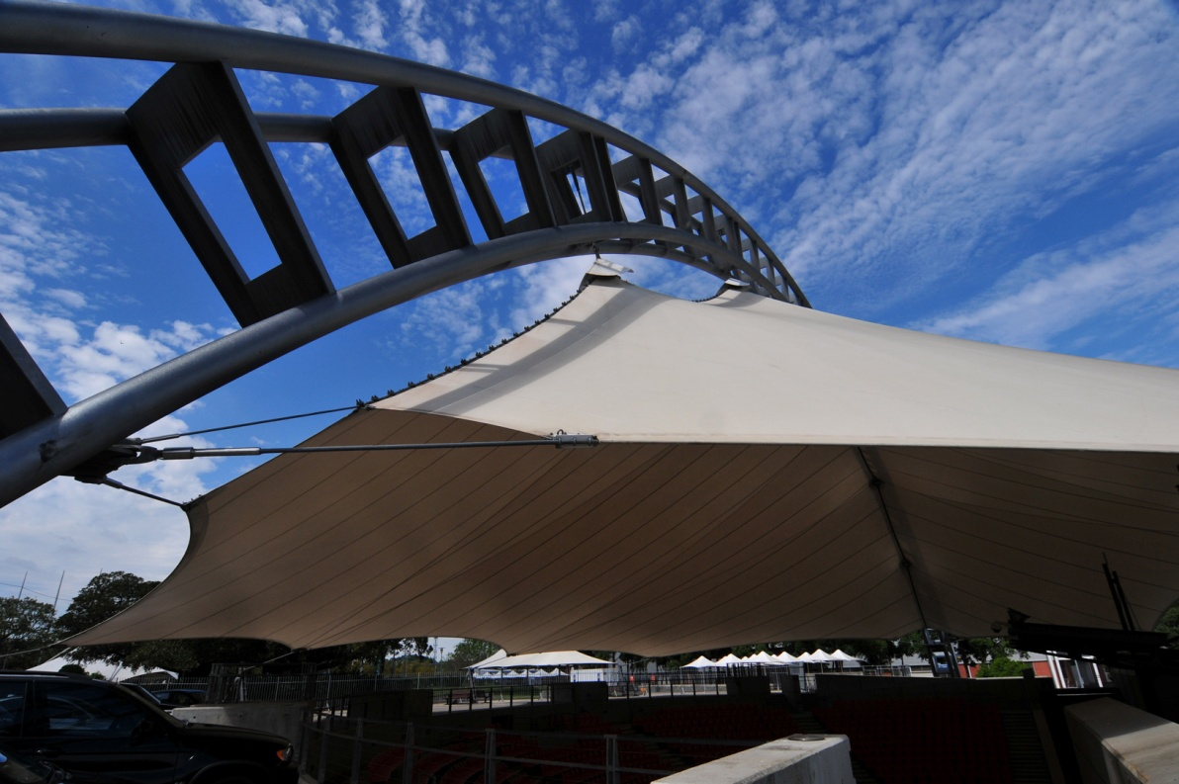

Public Lecture – “Lightweight Structures”

Professor Mike Schlaich
The Public Lecture is part of the LSAA2011 Conference “Collaborative Design of Lightweight Structures” but the public is able to attend this special lecture. If you are not attending the Conference you must register.
It counts towards Engineers Australia CPD requirements.
Sydney, Thursday October 13 2011
Cost $60 pp – Pre-registration essential – see form below
Check in during afternoon tea: 15.15
Lecture: 16.15 – 17.30
Venue - Novotel Hotel - Sydney Olympic Park
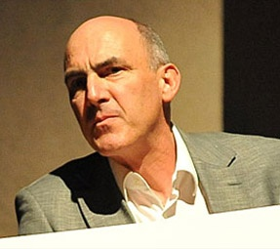 | Mike is Professor for Structural Engineering chairing the Department of Conceptual and Structural Design at Technische Universität Berlin (TU Berlin). He is also the Managing Director of Schlaich Bergermann und Partner, Consulting Structural Engineers, Germany. He studied civil engineering at the University of Stuttgart and ETH Zurich, and received PhD in civil engineering from ETH Zurich in 1989.  Mike worked in Spain as a structural engineer before joining in the firm of Schlaich Bergermann and Partner in Stuttgart which specializes in lightweight and long-span structures. He became Managing Director of the firm in 2002, which has been active in the field of renewable energies for more than 20 years. Systems for solar thermal energy production including dish-stirling concentrators, trough collectors and the solar updraft tower were successfully developed by the office.

Public Lecture: “Lightweight Structures”

Thursday October 13 2011 from 3.15pm – 5.30pm
Venue - Novotel Hotel Sydney Olympic Park

Cost: $60 per person.
Registration Form

Attendees:
Names. ___________
Emails: ______
Firm's Name:
Phone: ____________
Address: ______
Suburb, Postcode, State:
Payment – Direct Deposit preferred, NO Credit Card Facility, Cheques or Exact Cash on day OK:
If using Direct Deposits (preferred), please use as a Reference “LECT plus phone number”
and then email confirmation receipt to registration@LSAA.org
Direct Deposit Details: Date: Total Amount:
Reference Caption:
LSAA Bank Details (for direct deposit, email details): ANZ, Account: Lightweight Structures Association of Australasia, BSB: 013 267, Account: 3524 14135
Cheques (Made out to “LSAA”) Amount: Bank: BSB: Acc #:
Engineers Aust. Member? YES / NO Number: (For CPD Records)

RSVP (if by cheque) by Oct 4, 2011, to Peter Kneen, LSAA, 18A Freeman Ave, Oatley NSW 2223

